Given the root of a **complete** binary tree, return the number of the nodes in the tree.

According to [**Wikipedia**](http://en.wikipedia.org/wiki/Binary_tree#Types_of_binary_trees), every level, except possibly the last, is completely filled in a complete binary tree, and all nodes in the last level are as far left as possible. It can have between 1 and 2h nodes inclusive at the last level h.

Design an algorithm that runs in less than O(n) time complexity.

**Example 1:**

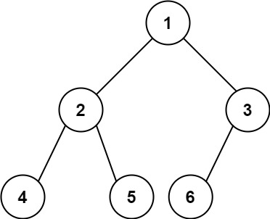

**Input:** root = [1,2,3,4,5,6]

**Output:** 6

**Example 2:**

**Input:** root = []

**Output:** 0

**Example 3:**

**Input:** root = [1]

**Output:** 1

**Constraints:**

* The number of nodes in the tree is in the range [0, 5 * 104].
* 0 <= Node.val <= 5 * 104
* The tree is guaranteed to be **complete**.